BookControllerTests

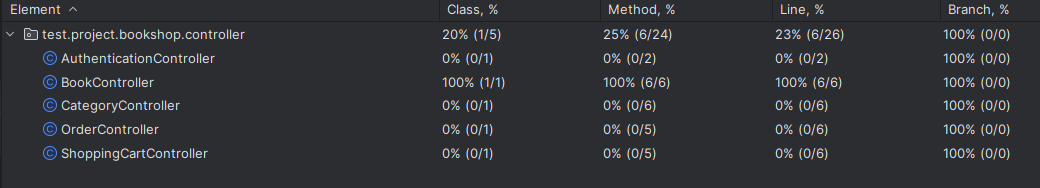

CategoryControllerTests

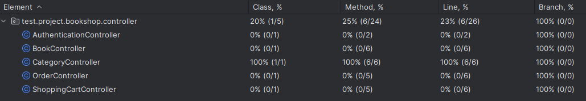

BookServiceImplTests

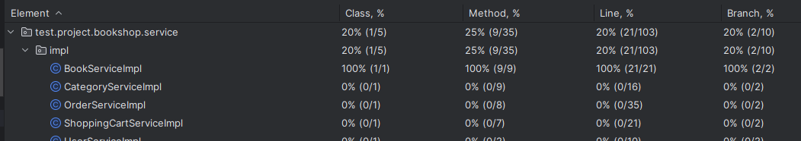

CategoryServiceImplTests  
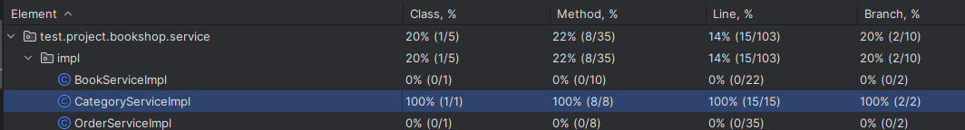

BookRepositoryTests

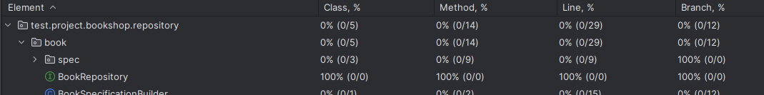

ShoppingCartControllerTests

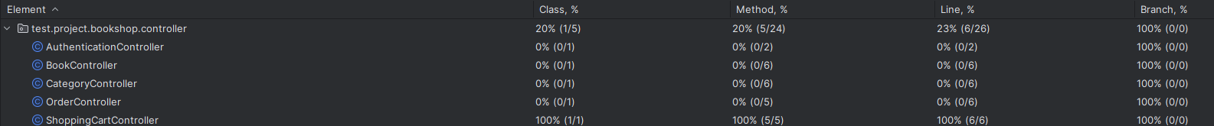

ShoppingCartServiceImplTest

